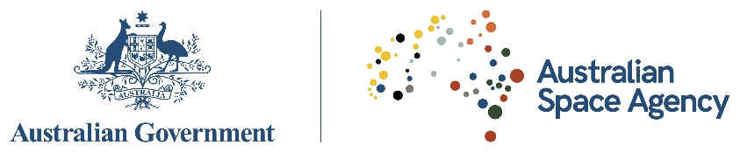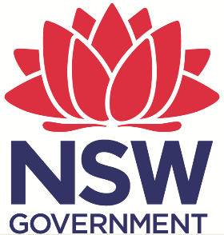

MEMORANDUM OF UNDERSTANDING

BETWEEN

THE AUSTRALIAN SPACE AGENCY

AND

THE NEW SOUTH WALES GOVERNMENT

REGARDING THE ADVANCEMENT AND GROWTH OF THE SPACE INDUSTRY SECTOR

The Australian Space Agency, an Agency of the Government of Australia within the Department of Industry, Innovation and Science, located at 10 Binara Street, Canberra City, Canberra (hereafter referred to as the “the Agency”);

and

The Crown in right of the State of New South Wales (NSW), acting through the Department of Premier and Cabinet, (hereafter referred to as “NSW Government”);

hereinafter referred to individually as “Participant” or collectively as “Participants”,

DESIRE TO BUILD on the cooperation already established between the Participants;

RECOGNISING the wishes of the Participants to mutually grow the size, scope, capability and commercial sustainability of Australia’s national space sector;

CONSIDERING the positive contribution that cooperation in supporting the development of infrastructure, science, research, technology, services and applications will bring to all industry organisations as well as academic and research institutions across the space sector;

RECOGNISING that the Agency’s purpose is to transform and grow a globally respected Australian space industry that lifts the broader economy, inspires and improves the lives of Australians – underpinned by strong international and national engagement;

RECALLING that the Agency areas of strategic priority include communications technologies, services and ground stations; position, navigation and timing infrastructure; space situational awareness and debris monitoring; research and development, including leapfrog technologies; earth observation services; remote asset management in space and on earth; space service and inspiring Australia, education and the future workforce;

RECALLING that the Agency is responsible for whole-of-government coordination of civil space matters and is the primary source of advice to the Australian Government on civil space policy including: providing national policy and strategic advice on the civil space sector; coordinating Australia’s domestic civil space sector activities; supporting the growth of Australia’s space industry and the use of space across the broader economy; leading international civil space engagement; administering space activities legislation and delivering on our international obligations; and inspiring the Australian community and the next generation of space entrepreneurs;

RECOGNISING that the NSW Government, under its Industry, Trade and Investment Strategy, is seeking to work with NSW small and medium sized enterprises (SMEs) aligned to the space sector to create economic prosperity in NSW through the further development of space industry capabilities, which will provide enabling technologies for innovation in the wider economy;

RECOGNISING the NSW Government has been providing assistance to the industry through international engagement and promotion of Australian space capability including through a joint NSW Department of Industry-Austrade space start-up mission to San Francisco, United States in August 2018, through representation at the 2018 International Astronautical Congress, and through programs such as the University of NSW TechConnect Space FlashBuild, funded by the NSW Government’s Boosting Business Innovation Program; and;

RECOGNISING the NSW Government is also investing in the long term growth of the aerospace and space industries through the Western Sydney Aerotropolis, which will align with the 2026 opening of the new Western Sydney Airport;

HAVE REACHED THE FOLLOWING UNDERSTANDINGS:

- Purpose

1.1 The purpose of this Memorandum of Understanding (‘MOU’) is to:

- provide a framework for mutual understanding between the Participants regarding common areas of interest and reviewing major areas of future cooperation to develop the space industry;
- facilitate the interchange of information in areas of mutual interest; and
- nominate relevant points of contact for both Participants.

- Areas of Cooperation

2.1 Subject to the laws and regulations applicable to them, the Participants, through consultation, will decide upon the specific items and scope of cooperation within the framework of this MOU. The proposed collaborative activities are as follow:

- Participants will facilitate collaboration as appropriate in NSW and Australian national space sectors, including:
  - working with the NSW Government’s Department of Industry and the Western City and Aerotropolis Authority in five focused sectors including: high tech instrumentation; ground communications and services; smart payloads development; space and intra-space communications, and; commercialisation of space data;
  - supporting the development of space skills and workforce capability;
  - leverage the emerging space start-up ecosystem in NSW both nationally and internationally, including NSW’s National Space Industry Hub and other facilities and entities that are developed in NSW relevant to the mutual objective of developing the national space sector;
  - collaborating with the NSW Government to leverage its network of international companies and financing organisations to facilitate the growth of the space sector;
  - supporting NSW businesses and academia in the participation in international space missions;
  - working collaboratively to design and develop the Western Sydney Aerotropolis and its space capabilities, including possible manufacturing, development and test facilities;
  - work alongside the NSW Government to coordinate NSW’s space industry activity and interface with the Agency; and
  - explore potential synergies in NSW’s National Space Industry Hub and the Western Sydney Aerotropolis.

- Participants will jointly identify suitable projects of common interest that can be supported and developed by both Participants. Other areas of cooperation may be identified by mutual consent of the Participants.

3 Financial and legal provisions

3.1 The Participants acknowledge that this MOU will place no financial, legal or other type of commitment on either Participant.

4 Implementation

4.1 The Participants will arrange meetings by mutual consent to review progress on this MOU. The persons nominated by the Participants as responsible for overseeing the implementation of this MOU are as follow:

For the NSW Government: Mr. Matthew Williams
Director, Investment Attraction
Department of Industry
Email: matthew.williams@industry.nsw.gov.au

Ms. Amanda Pearson
Director
Western City and Aerotropolis Authority
Email: amanda.pearson@wcaa.sydney

For the Agency: Mr. Karl Rodrigues
Executive Director, International and National Engagement
Email: karl.rodrigues@space.gov.au

or such other person notified to the other Participant.

4.2 The Participants acknowledge that the State and Territories Space Coordination Committee, as defined in the Agency’s Charter, will be used as the forum to review the Agency’s and all States and Territories progress to supporting the growth of Australia’s national space sector.

5 Amendment

5.1 This MOU may be amended by mutual consent of the Participants. The Participant wishing to make an amendment will notify the other in writing. Any amendment will take effect when each Participant has notified the other in writing of its consent to the amendment.

6 Status

6.1 Nothing in this MOU is intended to create any legally binding relationship between the Participants, nor is it intended to have any legal or binding effect on either Participant.

6.2 This MOU does not confer on the Participants any benefit or advantage in relation to any government contract, tender process or transaction or any application for a licence, permit or other authority under government legislation.

6.3 This MOU will be without prejudice to the cooperation of either Participant with other states, territories, space agencies or any other entity.

7 Duration and termination

7.1 This MOU will come into effect on the date of signature by both Participants and will continue in operation until terminated by either Participant giving one months’ written notice to the other.

Signed at NSW Department of Premier and Cabinet, 52 Martin Place, Sydney on 28 February 2019.

For  the Australian Space Agency:  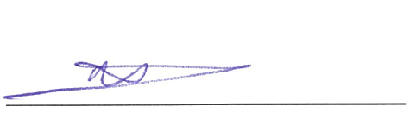  Mr. Anthony Murfett  Deputy Head | For  and on behalf of the NSW Government by its authorised officer:  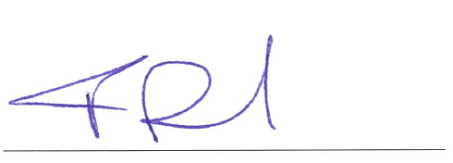  Mr. Tim Reardon  Secretary  NSW Department of Premier and Cabinet

