

**Joint Statement of Strategic Intent   
and Cooperation**

between

**Australian Space Agency**

and

**Myriota Pty Ltd**

Decorative image

**Australian Space Agency** [**space.gov.au**](http://space.gov.au)

 

# MYRIOTA PTY LTD STATEMENT OF STRATEGIC INTENT AND COOPERATION WITH THE AUSTRALIAN SPACE AGENCY

The Commonwealth of Australia as represented by the Australian Space Agency, part of the Department of Industry, Innovation and Science, hereinafter referred to as “**the Agency**” and represented by Dr Megan Clark AC, Head, Australian Space Agency,

and

Myriota Pty Ltd, hereinafter referred to as "**Myriota**" and represented by Dr Alex Grant, Chief Executive Officer, Myriota Pty Ltd;

*Recalling* that the Australian Civil Space Strategy 2019-2028 (Strategy) is a framework for the development and growth of the Australian space industry over ten years; underpinned by four strategic pillars: International; National; Responsible; and Inspire. Under these pillars the strategy outlines a plan to realise opportunities and address challenges by opening doors internationally; increasing national space capability; promoting responsible regulation, risk and space culture; and building the future workforce. The Strategy sets a path for the Agency to triple the size of Australia’s space sector to $12 billion and create another 20,000 jobs by 2030;

*Recalling* that the Agency's purpose is to transform and grow a globally respected Australian space industry that lifts the broader economy, inspires and improves the lives of Australians – underpinned by strong international and national engagement;

*Recalling* that the Agency has seven National Civil Space Priority Areas under the Strategy including communications technologies and services; position, navigation and timing infrastructure; space situational awareness and debris monitoring; leapfrog research and development; Earth observation services; robotics and automation on Earth and in space; and access to space;

*Recalling* that the Agency’s responsibilities include: whole-of-government coordination of Australia's civil space sector matters, providing primary civil space policy and strategic advice to the Australian Government, supporting the growth of our national space industry and the use of space across the broader economy, leading international civil space engagement, administering space activities legislation and completing our international obligations, and inspiring both the Australian community and the next generation of space entrepreneurs;

*Recalling* that Myriota is an Australian company specialising in the provision of Internet of Things data connectivity via low Earth orbit satellite;

*Recalling* that Myriota's strategic purpose is to enable Australian and global industries to obtain the sensor and location data they need to digitally transform their businesses, through:

* provision of massive scale, long battery life, secure data connectivity with global coverage;
* supply of innovative hardware components for connectivity and data processing; and
* fostering a developer community to produce a wide range of connected industrial sensors, devices and analytics solutions;

*Recalling* Myriota's depth of specialist telecommunications, space segment and ground segment knowledge and experience in research and development, intellectual property generation, design, production and operation of satellite communications products and services, uniquely equips Myriota to develop products for Australian markets and for export, contributing to the growth of Australia’s space sector in the strategic area of communications technologies and services;

*Recalling* that Myriota has attracted investment from strategic partners with strong international leadership positions in space, telecommunications and deep technology, including from CSIRO Innovation Fund 1, LP, Boeing HorizonX and Singtel Innov8.

*Acknowledging* that the Agency and Myriota share the objective of enhancing the capability and competitiveness of key Australian industries, and promoting investments in globally relevant space technology capabilities and space-based infrastructure, that will support economic growth and highly qualified jobs as well as improving the day-to-day lives of all Australians through innovative products and services;

*Acknowledging* that the Agency as an Australian government agency is committed to open, transparent and significant industry engagement;

*Acknowledging* that Myriota has a proven history of innovation and delivery of affordable connectivity solutions for agriculture, environment, utilities, maritime, transport, logistics and defence sectors, Myriota will continue to invest in space related and enabled technologies, capability and infrastructure in support of the Australian Civil Space Strategy;

Through this Statement, Myriota acknowledges the following current projects, areas of strategic interest and growth, potential new areas of collaboration and support for education and training which are of interest to the nation.

* Expansion and continuing development of a constellation of low Earth orbit nanosatellites and associated ground systems for the provision of direct-to-orbit connectivity, serving Australian and global industries. In its next phase of infrastructure investment, Myriota will expand its constellation to twenty-five satellites by 2022. This will further expand up to fifty satellites over subsequent years, providing real-time global coverage.
* Pursuit of opportunities to deliver sensor connectivity technologies for lunar and planetary exploration missions.
* Active engagement with STEM initiatives at all levels of education, including school visits and learning programs, provision of opportunities for internships and placements, and collaborations with Australian space and telecommunications research organisations. Myriota will offer up to ten internships per year across all aspects of the business.
* Myriota recognises the challenge of increasing gender diversity in STEM professions and will continue to support initiatives giving visibility to school children of female role models in technology companies, and university STEM programs for female students, partnering to provide opportunities for internships and graduate employment.
* Establishment of an Innovation Laboratory at Lot Fourteen, to facilitate partner collaboration and solutions, and delivery of training and education initiatives.
* Growing Myriota’s highly skilled workforce from 25 to over 50 by 2022.

This Statement constitutes the expression of both parties' intention to continue discussions. This statement does not create legal obligations between the parties and does not establish the obligation to enter into a certain agreement.

This Statement is signed in two (2) copies both at the offices of Myriota and the Australian Space Agency, Adelaide on 15 July 2019.

**On behalf of**

**The Australian Space Agency**

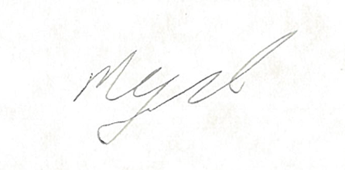

**Dr Megan Clark AC**

**Head of the Australian Space Agency**

**On behalf of**

**Myriota Pty Ltd**

**Dr Alex Grant  
Chief Executive Officer**

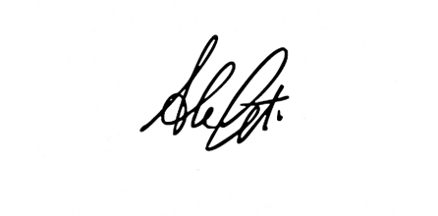

**Myriota Pty Ltd**