

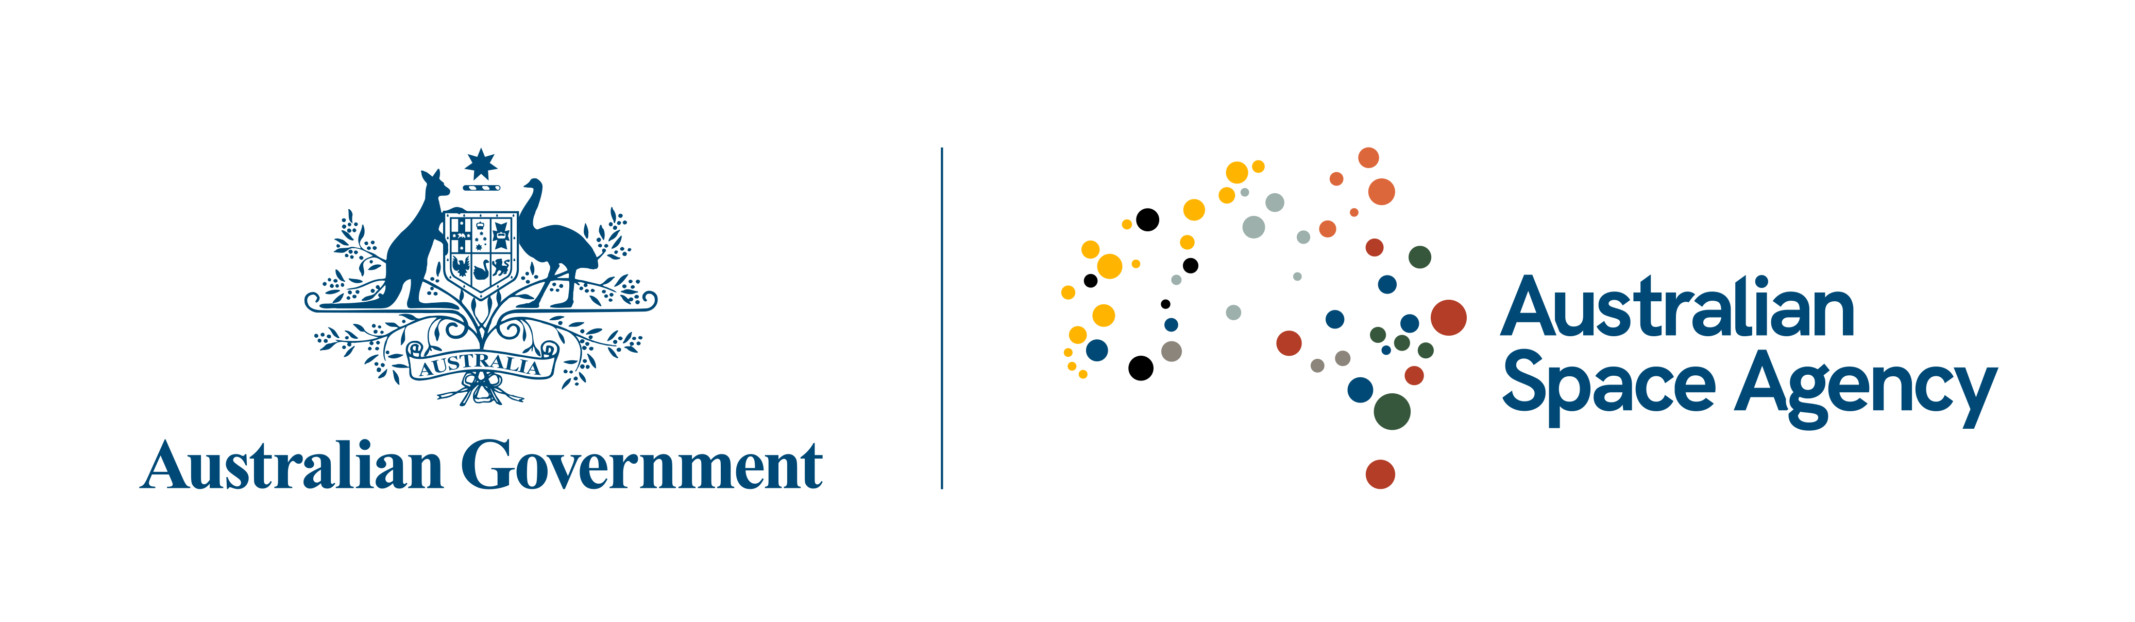

**Statement of Intent**under the joint Memorandum of Understanding (MoU) between the  
**Australian Space Agency**and the  
**Italian Space Agency  
to consider a joint Australia-Italy activity on the International Space Station**

The Australian Space Agency and the Italian Space Agency:

*Considering* the Memorandum of Understanding signed in Washington D.C. on 21 October 2019;

*Recalling* the advantages and benefits arising from international cooperation in the space industry;

hereby state their intention to consider a joint Australian-Italian activity on the International Space Station (ISS).

The Australian Space Agency and the Italian Space Agency will intend to investigate the opportunities to pursue a joint activity on board of the ISS to be implemented in the coming years.

The two Agencies intend to explore cooperation opportunities such as the development of pressurised and unpressurised payloads, the execution of scientific or technological investigations, and missions like CubeSat/Microsat deployment.

Both agencies acknowledge that such a joint activity will create an opportunity for space qualification and advancement of the Technology Readiness Level of identified systems and for advancements in scientific research.

This statement is intended to be the first step towards the negotiation of an Arrangement between the two Agencies. In parallel, technical and programmatic discussions will be continued to identify the aims, objectives, responsibilities and scope of joint activities.

Both Agencies look forward to advancing the Australian and Italian interests in the space domain, as well as further strengthening the bonds between their respective countries.

This statement does not create any legal obligation or financial commitment between the two Agencies and does not entail the obligation to enter into a specific Arrangement.

Signed in Adelaide on 17 February 2020, in two originals in the English language.

For

the Australian Space Agency:

For

the Italian Space Agency: