# Earth Observation from Space Roadmap 2021-2030

The material in this publication is licensed under a Creative Commons Attribution - 4.0 International licence, with the exception of:

* the Commonwealth Coat of Arms
* any third party material
* any trademarks, and
* any images or photographs.

The terms under which the Coat of Arms can be used are detailed on the following website: pmc.gov.au/government/its-honour

Wherever a third party holds copyright in this material, the copyright remains with that party. Their permission may be required to use the material. Please contact them directly.

More information on this CC BY license is set out at the Creative Commons Website. Enquiries about this publication can be sent to:

Australian Space Agency

Lot Fourteen, McEwin Building. North Terrace, Adelaide, SA 5000

Phone: 1800 087 367 (within Australia) / +61 2 6276 1166

Email: [enquiries@space.gov.au](mailto:enquiries@space.gov.au)

space.gov.au

The Earth Observation from Space Roadmap is an Australian Government publication that provides a vision for the next phase of Australian Earth observation capability development to drive economic growth and industry transformation. It is the second report in the Australian Space Agency’s Roadmap series.

© Commonwealth of Australia and the States and Territories of Australia 2021,

Published by the Australian Space Agency November 2021.

ISBN (print): 978-1-922125-97-2

ISBN (online): 978-1-922125-98-9

### Attribution

Use of all or part of this publication must include the following attribution:

© Commonwealth of Australia 2021, published by the Australian Space Agency.

### Citation

Australian Space Agency (2021), Earth Observation from Space Roadmap 2021-2030, November, available at space.gov.au

### Disclaimer

By accessing or using this publication, you agree to the following:

This publication is not legal or professional advice. Persons rely upon this publication entirely at their own risk and must take responsibility for assessing the relevance and accuracy of the information in relation to their particular circumstances.

## Head of Agency – Introduction



*Observing Earth from space can help address Australia’s biggest challenges and unlock economic opportunities for current and future generations.*

### Earth Observations from space

Our reliance on Earth Observation (EO) data and technologies has never been more profound, and they play a vital role in the fabric of our society. For example, insights from EO data are increasingly being used to inform agriculture and resource management practices, so farmers can manage their pastures and livestock over larger areas with greater precision. Natural disaster response and climate science also look to EO to model and mitigate the impacts of catastrophic weather events like bushfires and drought, which have significant economic and social effects on the community. Of note, the economic benefits to Australia attributable to EO data were estimated to be up to $2.5 billion in 2020.[1]

It is within this context that the vision of the EO from Space roadmap is founded. As the second technical roadmap to be delivered in accordance with the Australian Civil Space Strategy 2019-2028[2] (the Strategy), this roadmap explores EO as a National Civil Space Priority Area which can be further developed to advance Australia’s competitiveness and role as a responsible actor in civil space activities. In essence, the roadmap provides the vision, ambition and aspirational capability targets to support the growth of a globally respected and thriving industry in Australia consistent with the Australian Space Agency’s mission to triple the size of the national civil space sector to $12 billion and create an additional 20,000 jobs by 2030.

### Future proofing by building sovereign capability

Australia is heavily reliant on EO data from the international community. As such, there exists an urgent, growing need for the Australian EO sector to be better positioned to build sovereign capability, particularly for assured access to EO data for Australia’s national needs. These include measuring and mitigating climate change, providing better insights to growing the economy, and meeting particular sovereign capability requirements for defence and meteorology. Building capability and expertise within the nation to meet those needs in the next decade is critical.

This roadmap identifies broad pathways to achieve these goals, while its implementation will ultimately strengthen our international relationships, build Australian space manufacturing capability, help meet Australia’s sovereign needs, and create skilled jobs.

### Partnering for success

The EO from Space Roadmap is a collaborative venture achieved through ongoing cooperation across government, industry and the research sector. Creating a globally responsible and respected space sector that lifts the broader economy and inspires and improves the lives of Australians is a joint mission and one that will be realised through these strong partnerships.

This roadmap is symbolic of a pivotal moment in time for the Australian civil space sector; an opportunity that must be harnessed now to the benefit of our industry and society into the future.

**Enrico Palermo**

Head, Australian Space Agency

November 2021

**National Civil Space Priority Areas**

**Roadmap development approach**

*An aligned, connected, and informed Australian space sector that is united behind a shared vision for each Civil Space Priority Area and clear pathways to meeting our ambitions.*

**Roadmaps guiding principles**

Development of technical roadmaps for each of the Civil Space Priority Areas is an action identified in the national space pillar of the Strategy. The roadmaps serve to provide strategic direction for the sector, and to inform and guide opportunities to support the growth of the industry. Each roadmap identifies necessary activities and supporting conditions for achieving the vision in each Civil Space Priority Area on a 10 year horizon. Their development and implementation are guided by the following principles:

* Describe a pathway to uplift capability in a manner that enables the tripling of the size of the Australian space sector to $12 billion and the creation of up to an extra 20,000 jobs by 2030
* Identify and engage with opportunity - aligning activities by consulting widely and deeply with industry, researchers and government agencies
* Encourage organisations to invest resources and efforts where they want to pursue the opportunities identified in the roadmaps
* Reinforce the role of government as a partner, facilitator and regulator for, and customer of, the sector (in line with the Strategy, including its investment principles).

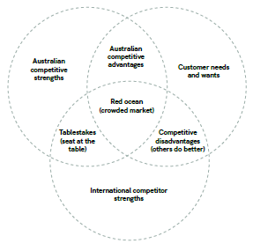

**Roadmap priorities and inclusions**

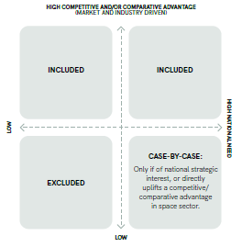

The roadmaps chart capability developments, rather than detailed technology developments, so industry and government researchers can drive innovation and have flexibility in their delivery.

To be included, a capability must:

* Strive towards bold visions and ambitions that align with the Strategy, and
* Have the potential to synergise with other selected capabilities to uplift the sector in an enduring manner, and
* Be based on a comparative or competitive advantage (a domestic government or commercial market opportunity for which Australia has a competitive strength), and/or
* Be an area of national strategic interest, or
* Be a necessary input to realise another included capability.

The roadmaps prioritise capabilities that are essential to the stated vision and ambition for each pathway. Opportunities exist outside the pathways that may still be pursued by the Australian space sector.

The roadmaps also include supporting conditions that would harmonise, support and facilitate the growth of these capabilities. These are prioritised according to their capacity to address challenges and foster opportunity.

**Approach to developing the roadmaps**

The Australian Space Agency worked together with industry, researchers and Australian Government agencies to develop each roadmap. Feedback and support to the validation of the assessments of Australia’s state-of-the-art capabilities, technologies and opportunities were provided by peer space agencies and stakeholder organisations.

**Phase 1: Assess opportunity**

* State-of-the-art assessments identify and evaluate Australia’s key strengths in the global context. Consideration is made for the ecosystem and value chain, spin-in potential from adjacent sectors, national application needs, strategic value, growth trends and market gaps.
* Australia’s competitive advantages are identified, with capabilities assessed and gaps validated along with their opportunities, risks and barriers.

**Phase 2: Set targets**

* A strategic direction is set via the definition of targets for 2030 including: the vision - an aspirational statement about Australia’s future capabilities, and the ambition - a positional statement about Australia’s future role.
* Focus segments are areas of greatest opportunity for the Australian space sector within the Civil Space Priority Area over the next decade. The focus segments interplay strategically to achieve the vision and ambition. Focus segments and related objectives (sub-visions), outcomes (sub-ambitions) and capability targets are defined based on identified opportunities.

**Phase 3: Devise pathways**

* Pathways are developed to set the action plan towards achieving the targets and roadmap objectives.
* The roadmap pathways diagram presents an action plan to be led by the space industry, and facilitated by the Australian Space Agency where appropriate, towards achieving the roadmap objectives.
* Capabilities are mapped along the core paths to the targets, together with external drivers that influence the roadmap. These should be captured or mitigated to progress the capability pathways and non-technical facilitating activities (facilitators).

**Phase 4: Enable implementation and monitor progress**

* The roadmaps will guide future investment in Australian industry and inform Australian Space Agency activities under the four space pillars in the Strategy.
* Progress against the roadmaps will contribute to the Australian Government’s goals to grow the industry. Their development during Phase 2 of the Strategy ‘Engaging with Opportunity’ (2019 to 2020) will support Phase 3 - ‘Delivering Success’ (2021 to 2028). Progress will be monitored via future State of Space reports and other publications.
* The roadmaps will be updated regularly to allow for refinement as the sector develops.

**Roadmaps audience**

The roadmaps are for all Australian space sector stakeholders, including industry, governments, researchers, the future workforce, investors and international partners. The roadmaps can also inform stakeholders in adjacent sectors, including mining and energy, defence and national security, agriculture and natural resources, remote medicine, and environmental and disaster management. These stakeholders could extend their existing capabilities into the space sector, leverage expertise in the space sector or become customers of the sector.

**Seven interconnected roadmaps**

The Civil Space Priority Areas are interconnected, reliant on cross-cutting technology areas, facilitated by non-technical enabling activities, and may be applied to many cross-cutting services.

The roadmap for each Civil Space Priority Area details the significance of these factors to its implementation. The roadmaps nexus illustrates the strategic interplay of these important categories.

The roadmaps identify areas of opportunity for industry including investment, as well as identifying areas where government could provide effective investment to deliver on the Strategy. They also link to a range of cross-cutting technology areas, for example there are strong links between these roadmaps and the Modern Manufacturing Strategy where space is a priority sector.

**Roadmaps nexus**

**Identifying growth activities**

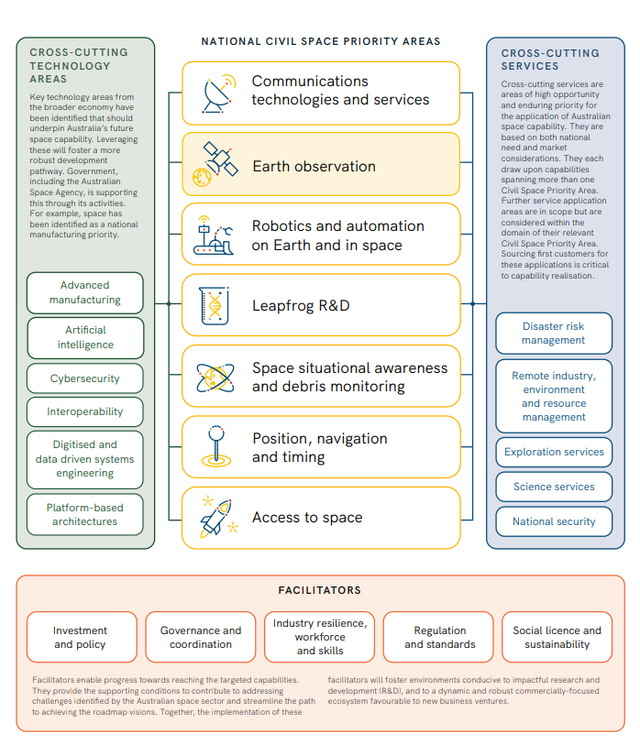

**Diagram: NATIONAL CIVIL SPACE PRIORITY AREAS**

Communications technologies and services, Earth observation, Robotics and automation on Earth and in space, Leapfrog R&D, Space situational awareness and debris monitoring, Position navigation and timing, Access to space.

**Cross-cutting technology areas**

Key technology areas from the broader economy have been identified that should underpin Australia’s future space capability. Leveraging these will foster a more robust development pathway. Government, including the Australian Space Agency, is supporting this through its activities. For example, space has been identified as a national manufacturing priority.

Cross-Cutting Technology Areas boxes: Advanced manufacturing, Artificial intelligence, Cybersecurity, Interoperability, Digitised and data driven systems engineering, Platform-based architectures.

**Cross-cutting services**

Cross-cutting services are areas of high opportunity and enduring priority for the application of Australian space capability. They are based on both national need and market considerations. They each draw upon capabilities spanning more than one Civil Space Priority Area. Further service application areas are in scope but are considered within the domain of their relevant Civil Space Priority Area. Sourcing first customers for these applications is critical to capability realisation.

Cross-Cutting Services boxes: Disaster risk management, Remote industry, environment and resource management, Exploration services, Science services, National security.

**Facilitators**

Facilitators enable progress towards reaching the targeted capabilities. They provide the supporting conditions to contribute to addressing challenges identified by the Australian space sector and streamline the path to achieving the roadmap visions. Together, the implementation of these facilitators will foster environments conducive to impactful research and development (R&D), and to a dynamic and robust commercially-focused ecosystem favourable to new business ventures.

Facilitators boxes: Investment and policy, governance and coordination, Industry resilience, workforce and skills, Regulation and standards, Social licence and sustainability.

**The value of EO to Australians**

The global EO market[3] is estimated to be worth USD2.7 trillion[4], with half of that in the APEC economies alone[5]. However, the true impact of EO resides in the insights and understanding we gain of our planet, its environments and human activities.

Australia has one of the largest Exclusive Economic Zones[6] in the world with 10.2 million square kilometres of ocean, including around the Australian Antarctic Territory. In addition to 7.7 million square kilometres of land, Australia’s vast territory has diverse ecosystems, climates, landforms, water bodies and maritime environments and these shape our lifestyle and our economy.

The processes of managing, using and responding to the natural environment, designing and building infrastructure and understanding the impacts of our population are critically reliant upon EO, particularly from space.

EO data delivers decision-critical information to government, industry, scientific and education institutions, and individuals. It can provide critical information to frontline responders on devastating fires by providing imagery of where fire is burning and information on where it is progressing, help farmers improve agricultural productivity by providing insights to where water resides, and provide accurate and reliable data for weather predictions and long-term climate forecasting.

The assured supply of quality EO data provides the basis for a small but growing part of the Australian economy employing thousands of individuals: EO data analysis and services that support industry and government.

In providing this information, the Australian EO from space sector directly contributed $283 million in value to the Australian economy and employed 1,570 Full Time Equivalents (FTEs) in 2020. The wider economic benefits attributable to EO data were estimated to be in the order of $2.5 billion in 2020.[7]

EO from space also meets national security, defence and meteorological needs. Australia has the world’s largest maritime search and rescue region and Security Forces Area of Authority, covering over one-tenth of the Earth’s surface. Australia’s economy is critically dependent on global trade, with 99 per cent of all exports reliant on maritime transport, making safety, security and environmental protection of Australia’s maritime domain a national security and economic imperative.[8] Defence needs geospatial information and intelligence capabilities to support strategic intelligence requirements throughout the Indo-Pacific region.[9] The Bureau of Meteorology (BOM) needs assured access to EO data for real time weather situational awareness, and to support the Numerical Weather Prediction (NWP) modelling capability that underpins all Australian weather forecasts and climate modelling, critical to disaster mitigation such as during bush fires, floods and volcanic activity in the region.

EO data fosters a vibrant research community by providing data that supports for example, environmental, maritime and built environment research. It also supports a growing industry that develops applications for end-users, such as crop monitoring and beach management, creating jobs and increasing Australian prosperity.

EO data is essential for:

* The delivery of critical services such as weather forecasting, disaster and emergency response,
* Enhancing economic productivity in key industries including agriculture, transport and insurance, measuring and monitoring sustainable development within our environment,
* Meeting maritime safety, national security and Defence data requirements, and
* Supporting the nation to deliver on its international commitments such as 2030 Agenda for Sustainable Development[10]; Paris Climate Agreement[11] and Sendai Framework for Disaster Reduction[12].

**EO from space enables:**

* **Socioeconomic game changers.** Increased availability of trusted and targeted EO data catalyses the development of end-user applications for effective decision making for example, understanding the availability and quality of water. Improving data for effective decision making lifts social wellbeing and provides economic benefits to all Australians.
* **Future workforce.** A high-tech STEM workforce will emerge based on new jobs in high growth areas across the entire EO data chain: space systems engineering, avionics, assembly integration and test (AIT), software, technical roles in ground based systems and maintenance in rural areas, application development, data analytics, EO science and research, artificial intelligence (AI) and machine learning (ML) and wider EO-centric business opportunities.
* **Increased security and resilience**. Australia is safer with EO-supported maritime surveillance that allow us to map marine pollution, identify illegal exploitation of natural resources and manage maritime traffic. Our resilience to natural disasters is enhanced when EO is used to rapidly understand the location, size and severity of disasters; it also better equips us to plan and oversee response and reconstruction.
* **Increased productivity.** Targeted insights from EO data leads to better management of Australia’s resources including agriculture, water, minerals and land, through improved decision times and better utilisation of time and resources.
* **Downstream development.** Innovation in the use and manipulation of data (the ‘downstream’) from space EO leads to an expansion of the applications for space derived data and services, leading to new businesses in data analytics and new ways to solve global challenges - increasing productivity and catalysing economic growth.
* **Economic growth.** EO upstream manufacturing and the downstream spatial capabilities grow the wider economy through direct job creation, supply chain opportunities and flow-on benefits such as improved weather forecasting, agricultural productivity, resource management and disaster relief.

**What is Earth Observation?**

EO encompasses a broad suite of remote sensing activities that gather observations of the full electromagnetic spectrum and produce measurements and spatial data to monitor and examine our planet, its environments, human activities and infrastructure.

EO data is used for measuring and mapping:

i. Categories of features, such as land use and cover, mineral deposits, infrastructure, roof types, weeds and road and ship traffic.

ii. Biological or physical properties, such as vegetation heights, fuel loads, crop yields, soil moisture, water depth, water quality, water run-off, building heights, cloud height and thickness, temperature, precipitation, sea surface winds, wave heights, currents, sea ice, snow cover, oil spills/seep, urban pollution and more.

iii. Changes in (i) and (ii) over time such as the detection of crop growth, or vegetation clearing, vertical profiles of aerosols, forest structure, sea surface topography, atmospheric wind direction and strength, ocean wave directions and strength, urban growth, development and disaster detection and recovery.

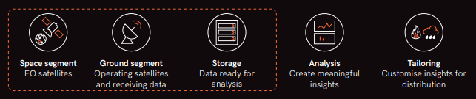

The EO supply chain includes the broad elements indicated above. This roadmap is focused on the first three: Space segment, Ground segment and Storage. Analysis and Tailoring provide vital insights to the design of the first three but are guided by roadmaps and plans developed by geospatial groups and organisations.

Collection of observations can use a variety of platforms: satellites, aircraft, remotely operated vehicles, and in-situ sensors. This roadmap is concerned only with satellite platforms; other platforms may be used to test EO instruments before deployment in satellites and to validate satellite data.

**Mission purpose**

*Operational:* Support ongoing decision making. Usually comprises of multiple series; high reliability and availability needs.

*Science:* Explore the utility of a mission concept or test scientific theories. May transition into an operational mission; can be designed to provide high or low reliability and/or availability depending on mission requirements and constraints like budget.

**Sensing principles**

*Passive:* Measure naturally available energy from the Earth; usually reflected sunlight (e.g. imagery).

*Active:* Emit energy (e.g. radar) and process the reflections to form images; works day and night and can work through cloud.

**Tasking**

*Taskable:* Satellite missions that allow the user to collect specific areas at specific times.

*Non-tasking:* Satellite missions that collect continuously according to a long-term program.

**User focus**

*Commercial:* Provided to fee-paying customers that include individuals, industry and government. Government is often the anchor customer for operational commercial missions.

*Public:* Provide data freely and openly to benefit all countries, such as through the Global Observing System (GOS). Governments around the world fund missions that comprise the GOS.

The provision of a store of data that is ready for analysis makes the data accessible to a wider range of users, increasing utilisation.

The ground segment allows EO satellites to be operated and to download data. It includes antennas, communications equipment and processing systems. Ground stations need reliable power, network connectivity and regular maintenance.

EO Imagery examples captions:

* Full disk seen from Himawari in GEO.
* Queensland coast bushfires as seen by Himawari.
* True colour composite appears as the human eye sees. This example is at 10 m spatial resolution from Sentinel 2.
* False colour composite includes non-visual wavelengths (near infrared in this example) to show plant density and health. This is one of the earliest examples, from Landsat 1 in 1972 at 80 m spatial resolution.
* Thermal infrared shows surface temperature with 100 m spatial resolution from Sentinel 2.
* Synthetic Aperture Radar (SAR) is an active imagery method that can image through clouds, day and night. This example is at a 10 m spatial resolution from Sentinel 1.
* Panchromatic captures much of the visual wavelengths in a single band and appears like a black and white photo. Usually much higher spatial resolution.
* Aerosol index showing UV absorbing aerosols in the atmosphere at 7 km x 3.5 km spatial resolution, from Sentinel 5p.
* True colour composite appears as the human eye sees. This example is at 1,000 m spatial resolution from the MODIS mission.
* Short Wave InfraRed (SWIR) showing plants in green, soil and urban structures in brown and water in black at 20 m spatial resolution. SWIR is also useful for showing newly burned land and mapping surface geology.

Imagery above is of Cairns, Queensland, Australia unless noted otherwise

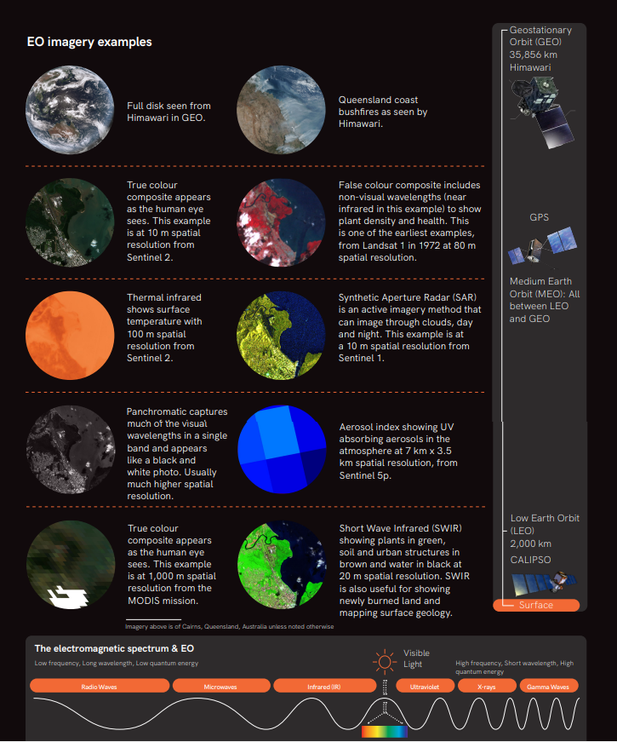

**Where are we now?**

*EO data is critical to Australia, and there is growing potential for EO space systems[13] to add more value to the economy, national security, Defence and society.*

**Satellite missions will support future EO needs**

Australia requires reliable and accurate EO data from space to function on a day-to-day operational basis.

Currently, Australia relies entirely upon other nations and foreign companies for EO data to support critical data needs for weather forecasting, environmental management, disaster preparedness and response. Denial of supply from other nations is considered unlikely, but a move by other nations to commercially source EO data would affect the free and open supply that Australia currently enjoys. As Australia’s dependency on EO grows, so does the impact of an interruption to data supply.

The global observing system is critical to Australia, and there is no intent to replicate it. However, Australia now has the potential to also make valued contributions to it, by focusing on unique national needs and competitive strengths, to help ensure continued access to EO data.

**Market gap**

Australia has niche EO requirements that afford the opportunity to develop new EO capabilities and EO data streams designed specifically for Australian user and market needs.

For example, Australia needs specific combinations of spatial, spectral, radiometric and temporal resolutions that allow collection against the typically small inland water bodies and narrow rivers found across the Australian land mass. Also, standing eucalyptus forests have specific spectral signatures not currently targeted by existing EO satellites, but that could be addressed with Australian systems.

Sovereign capability needs for operational defence, border security, PNT, land imaging and meteorological EO systems present considerable and enduring gaps that can be filled by a mature Australian industry.

**Government role**

The costs of operational EO satellite systems have fallen but can still be significant. Government remains the largest customer for EO data around the world, either through deploying public-good constellations (e.g. Landsat, Sentinel, Himawari) or as the primary customer for high resolution, taskable constellations.

Government needs represent one of many opportunities to support the growth of the industry, develop operational capability, access international supply chains, and contribute to other nations’ missions.

For example, the Australian Defence Organisation has recognised the need for sovereign EO capabilities with enhanced coverage of the Indo-Pacific region, and plans to spend up to $7.1 billion on sovereign satellite imagery capabilities.[14]

Other Government needs are expected to evolve, including: mapping, climate and weather, support to sustainable development, environmental management, biosecurity, disaster management, security and surveillance, and location-based services.

The Modern Manufacturing Strategy - the $1.5 billion Government investment to help Australian manufacturing scale, become more competitive and more resilient also recognises space manufacturing as one of the key priority areas, which provides an opportunity to support the growth of EO from space capabilities. [15]

**Australia’s spatial expertise will identify opportunities**

Australia’s EO community has deep knowledge of how to best utilise EO data. GA has been working closely with the United States Geological Survey (USGS) Landsat Sustainable Imaging program’s EO data for over 40 years.[16] This community links government agencies, research bodies, education institutions and private industry, and has excellent connections to the global EO community. This expertise and cohesion enables the identification of data gaps and facilitates the development of activities, mission concepts and instrument specifications that fill those gaps through Australian missions and direct involvement in international missions.

Successfully filling niches and partnering is an effective strategy that avoids actual or perceived duplication of effort and develops new applications and markets for EO data, creating high value EO investment opportunities that give investors’ confidence.

**New and future technology**

Australian industry’s strength in Earth asset observation via satellite-enabled Internet of Things (IoT) and Radio Frequency (RF) monitoring can augment traditional EO data by adding in-situ measurements and locations that deliver deeper insights for end-users.[17]

Looking further ahead, Australia’s strengths in quantum technology provide the foundation for the development of quantum sensing to meet emerging needs for non-traditional EO methods.

**Australian space sector priorities for EO**

1. Support a sustainable industry in Australia that can build satellites and payloads capable of meeting niche national data needs, making valued contributions to international missions, supporting economic and industry growth, and providing resilience for Australia’s defence, meteorological, environmental and climate monitoring needs.
2. Build on Australia’s leadership as a data integrator for EO, through roles on international coordination bodies.
3. Ensure continued Australian access to the trusted international EO data that supports Australia’s EO sector.

**Vision**

EO data will increasingly support the Australian community by enabling essential government and industry capabilities including meteorology, environmental, agriculture and infrastructure management, disaster response, defence and national security; it will be informed by the data needs of the broader spatial community and it will also enable businesses that design and deliver EO-based products and services.

**Ambition**

Australia will complement its ground infrastructure, research, data quality and data management expertise with the ability to develop EO missions that deliver niche data to the downstream industry and make valued contributions to the global observing system. Government will enable science teams and international partnerships that facilitate industry to design and manufacture space and ground-based systems capable of collecting and quality-assuring reliable, precise and accurate EO data to meet Australia’s operational government, commercial and scientific needs.

**Focus Segments**

Five focus segments have been identified for Australia’s Earth Observation from Space Roadmap.

These are considered to be the areas of greatest opportunity for Australia’s space sector, where there is high potential to deliver capabilities and services to the civil EO market, and also to meet Defence needs for resilience through the supply of EO collection capabilities.

A range of manufacturing opportunities reside in each of the focus segments, for example the manufacturing of satellite buses and sub-systems, payloads and instruments, ground segment equipment, calibration and validation sensors and infrastructure.

* Australian EO missions and payloads

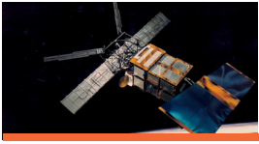

* Data quality assurance and integrity monitoring

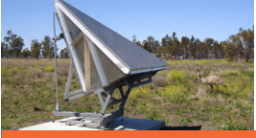

* Enhanced data management



* International EO partnership and leadership



* Access to international data and missions

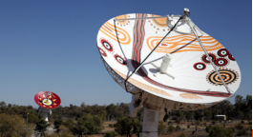

[Floating quote:] *“Earth observation data is no longer just a research activity. It informs policy, helps manage natural environments, assists recovery from major catastrophes and generates agricultural and industrial development opportunities,...”*

*Dr Alex Held, Director, CSIRO Centre for Earth Observation*

**Facilitators**

*The Australian Government will continue to work across the stakeholder community to grow the economy and create jobs by ensuring the conditions are right.*

**Investment and policy:**

* Since the establishment of the Australian Space Agency in 2018, the Government has committed more than $800 million to grow the civil space sector and create jobs.
* This includes the Australian Government investment to implement the Strategy includes $235 million through the Australian Space Agency. This consists of $150 million to support Australian participation in NASA’s Moon to Mars ambitions, the $19.5 million Space Infrastructure Fund, $6 million for the Australian Space Discovery Centre, the $15 million International Space Investment initiative, and funding for the ongoing operations of the Australian Space Agency.
* The Government has also committed over $390 million through GA to provide Satellite Based Augmentation of GPS and continue development of Digital Earth Australia, as well as $67 million to support new technologies for space through the SmartSat CRC.
* Through CSIRO, Government has invested over $35 million in new space facilities and programs, including the NovaSAR-1 National Facility, in addition to ongoing EO research.
* Phase 1 of Defence’s DEF799 program began investing $500 million in 2017 to improve Australia’s access to commercial satellite imagery. Planned investment of up to $6.6 billion for sovereign satellite imagery capabilities[18] over the period of 2020-2040 presents a significant opportunity for a mature Australian satellite EO industry.
* Defence has provided $12 million to the SmartSat CRC and will invest $50 million in the Australian space industry over 15 years to support satellite communication technology.
* The benefits of Government support for the establishment of the upstream sector have been identified by the House of Representatives Inquiry, Modern Manufacturing Strategy, and through Industry and Technical Advisory Group consultations.
* The Australian Space Agency will continue to focus on the four space pillars under the Strategy: International, National, Responsible and Inspire. The Agency will facilitate industry and provide advice to government on opportunities to grow Australia’s space industry in line with the roadmaps.

**Governance and coordination:**

* Coordinate the articulation of the value of EO data to end-users.
* Facilitate ongoing access to international data critical to Australia’s EO needs through coordination of relevant areas of government, industry and the broader community.
* Ensure the security of sovereign EO capabilities, supply chains, data, IP and IT systems through coordination of relevant areas of government, industry and the EO community to develop integrated and robust security risk management frameworks.
* Coordinate processes and programs to collect end-user data requirements that drive the design of EO mission concepts.
* Employ the Australian National Ground Segment Technical Team (ANGSTT) to coordinate ground segment development where appropriate.
* Provide strategic advice to government on opportunities for national missions as informed by the roadmaps to support end-user needs.
* Coordinate the development of visions and pathways across the space sector, State and Territory governments and communicate these domestically and internationally.
* Support Australian obligations to international treaties, strengthen domestic science and technology bilateral agreements, Statements of Strategic Intent (SSI), and agreements with researchers, industry and other space agencies.
* Strengthen international relationships with various bodies including but not limited to Committee on Earth Observation Satellites (CEOS), Group on Earth Observations (GEO), Japan Meteorological Agency (JMA), United States Geological Survey (USGS), and the World Meteorological Organisation (WMO).

**Industry resilience, workforce and skills:**

* A high tech, skilled workforce is required for all elements of space mission engineering, design, manufacture, operation and disposal. Relevant education, training and experience is critical to enable industry, academia, science bodies and to inform government.

**Regulation and standards:**

* Technical regulation frameworks and standards for space systems where appropriate.
* System Engineering standards and frameworks to support traceable design of the right systems to meet stated needs.
* Consideration of international standards to facilitate cooperation and interoperability with international partnerships.

**Social licence and sustainability:**

* Effective, ongoing communication of the criticality of EO data from space for the Australian economy and larger global challenges, is needed to support the growth of workforce and build social license to support increased investment.

**Australian EO missions and payloads**



*The capability to develop Australian EO missions and payloads will enable Australia to assure and widen the provision of trusted data to downstream end-users. This will contribute data sources to global observing systems and improve Australian space manufacturing capabilities in this decade.*

**OPPORTUNITY**

Australia has the potential to complete its EO ecosystem by manufacturing EO satellites and payloads, informed by our expertise in EO data utilisation. This would strengthen our capacity to:

* build Australian satellite manufacturing capability for EO, providing the experience necessary to meet Defence, GA and BOM EO needs in the next decade
* provide a needed contribution to the global EO system that ensures continued access to vital international EO data
* mitigate natural disaster risk through the collection of niche EO data of particular relevance to Australia
* develop a skilled and experienced manufacturing workforce that can support other parts of the space sector and broader economy as well.

Upstream space activities are no longer cost-prohibitive but they remain a significant investment and require strategic consideration. The cost of establishing the ability to manufacture operational EO satellite systems and payloads has historically been met by governments in space-faring nations. This focus segment highlights the opportunity to leverage government purchasing power as well as opportunities for industry to support the growth of Australia’s space industry that will deliver key capabilities for government.

Indicators of success include increased capability in Australia in the following areas:

* Space program and project management
* Space missions System Engineering life cycle from mission design to disposal
* Scalable and sustainable manufacturing of mission-critical ground and space subsystems
* Operational payloads developed for Australian and international primes
* Space Missions procurement processes
* Spacecraft integration, testing and qualification, operations and disposal
* Launch integration and access to space
* Calibration and maintenance
* International supply chain opportunities
* Technology Readiness Level (TRL) raising processes for translating research to operational technology

*Note: Other valuable mission purposes and associated technologies are identified in the pathways chart and could be progressed through a coordinated technology development program.*

**OBJECTIVES**

By 2030, Australia has all the necessary capabilities across the design, build, qualification, operation and disposal phases of mission lifecycles for appropriately sized EO satellites for applications identified as per national needs in the roadmap. These capabilities will also meet commercial mission needs.

**OUTCOME**

Australian industrial satellite manufacturing capabilities have been established that allow the nation to fulfil Australian operational and scientific EO needs, complementing and consistent with Australia’s established International EO relationships, obligations and agreements.

Governmental capacity to lead national missions where appropriate and to support Australian industry to access national and global opportunities including supply chains.

Space manufacturing capabilities are scalable and transferable to support other strategic civil space priority areas, with the creation of hosted payload opportunities and interoperable platforms.

Australian space manufacturing industry meets its decadal objectives as identified in the Space National Manufacturing Priority Roadmap – goals and benchmarks.

**SEGMENT TARGET CAPABILITY**

Australian industry that can design, build, qualify and operate EO missions and payloads.

**Australian missions: now and the future**

Several mission concepts have been identified as a part of the roadmap process. The mission concepts are expected to evolve and new needs are expected to be identified over the course of the decadal implementation of this roadmap.

**Priority mission purposes**

The following mission purposes are considered the highest priorities for Australia:

* Satellite cross-calibration radiometers to support improved calibration of international operational EO missions and improved interoperability of data from different satellites
* National water quality monitoring – with international scalability
* National bushfire fuel load monitoring – with international scalability
* Operational meteorological data collection, including in geostationary orbit
* National maritime surveillance capabilities

**The following descriptors are used for Australian, National and Sovereign Missions:**

**Australian missions**: Made in Australia for any purpose, including government or commercial.

**National missions**: Providing a service for a national purpose. May be owned or operated by any company or country; Australia may not have full control of tasking or download.

**Sovereign missions**: Providing a service for a national purpose. Completely responsive to Australian entities and their priorities.

**Data quality assurance and integrity monitoring**



*Australia’s southern position and unique and diverse range of environments make it ideal for the quality assurance of data from international and domestic satellite EO missions. These environments include arid and semi-arid biomes, large cropping areas, forests and tropical rainforests, coastal and aquatic areas, alpine regions, vast tracts of ocean, and via Antarctic facilities, access to polar environments, glaciers, and ice sheets.[19]*

**OPPORTUNITY**

With Australia’s geographic advantages, long standing international engagement and world-class calibration and validation infrastructure[20], the primary opportunity for calibration and validation in Australia lies with establishing a coordinated network of quality assurance sites for operational and research purposes[21] to support Australian and international missions.

Establishing an Australian Centre for EO Quality Assurance (ACE-QA), tools and support to satellite operators to utilise the infrastructure via ACE-QA and Australian owned and operated Satellite Cross Calibration Radiometers (SCR), delivers further operational capabilities.[22]

Opportunities also exist to apply calibration and validation expertise to support various Australian and international remote sensing missions including but not limited to hyperspectral, radar, soil moisture, water heights, and also remote sensing for lunar exploration.

**OBJECTIVE**

* A holistic, marketable capability that allows international partners and Australian missions to certify their EO data as meeting spatial, spectral and radiometric quality standards.
* Exploration of leapfrog concepts including AI and edge computing.
* The application of calibration and validation to off-Earth exploration and settlement activities is verified.

**OUTCOME**

An Australian ‘quality stamp’ on EO data ensures that data, services and analytical results are trusted.

Calibration and validation sites, facilities, systems, personnel and expertise resident in Australia are widely used for international and Australian missions, including Defence and meteorology, reinforcing Australian roles in global EO bodies.

Australian industry transitions expertise on in-situ calibration and validation to support off-Earth exploration and infrastructure in the 2030s.

**SEGMENT TARGET CAPABILITY**

* Operational national calibration and validation capability.
* A data integrity monitoring function for public and private missions that leverages national calibration and validation capability.

**Enhanced data management**



*Australia continues to make valued contributions to the global observing systems. Australia supports the Australian EO data user community, including the commercial sector, through enhanced data management approaches and coordinated processes to collect end-user data requirements.*

**OPPORTUNITY**

Australia has EO utilisation expertise at research organisations, industry and at all levels of government. Experts take EO data and develop products and services that meet the needs of end-users.

Developing next generation, secure storage and management capabilities to provide EO data in an analysis ready state is an enabler of those EO experts as they provide the foundation for the development of responsive, trusted products and services.

Australia is well equipped to exploit this opportunity as it builds upon our extensive history in managing EO data, using both publicly and privately developed systems like Open Data Cube and Copernicus Australasian Data Hub. Australian expertise in this area is recognised around the world, including by governments, philanthropic organisations and commercial EO operators.

Developments in data management technologies including secure cloud storage and compute, advanced analytics using AI, ML and integrated pipelines support this opportunity for Australian industry to lead the next generation of advances in EO data management.

**OBJECTIVE**

* Bolster Australia as a global centre of excellence for EO data management.
* Development of extant and next generation, secure and analysis ready EO data storage and management systems.
* Inform data management processes in other National Civil Space Priority Areas, including Space Situational Awareness and Debris Monitoring and Robotics and Automation on Earth and in Space.

**OUTCOME**

Australian businesses and other EO experts can access analysis ready EO data and transform it into marketable systems, services and products.

New markets for EO data, products and services are established, growing both the EO and end-user industries through improved decision making.

**SEGMENT TARGET CAPABILITY**

* EO data management systems employing advanced AI, ML tools and blockchain based provenance with all local and cloud storage and compute models.
* Develop EO data sales model from whole images to only those pixels of interest to the customer.

**International EO partnership and leadership**



*Australia builds on its expertise in EO science and research and uplifts its contributions to international partnerships to generate the next generation of collaborations and industry opportunities.*

**OPPORTUNITY**

Joint science missions, industrial partnerships and continued leadership roles in global EO governing bodies facilitates knowledge transfer that supports industry, innovation and growth.

The Australian EO science and research community has long standing international partnerships that enable Australian collaborations in various EO science missions, including through mission and payload development, calibration and validation activities and data management expertise.

The Australian Government has formed numerous partnerships with global EO networks. CSIRO manages bilateral agreements with the European Space Agency and Centre National d’Etudes Spatiales, and operates a 10 per cent capacity share of UK NovaSAR-1 as a national facility. GA has a longstanding partnership with the United States Geological Survey (the USGS). BOM has a longstanding close working relationship with the Japan Meteorological Agency and the National Oceanographic and Atmospheric Administration.

Together, GA, CSIRO and the BOM have a strong presence in the Group on Earth observations (GEO), and Committee on EO Satellites (CEOS).

**OBJECTIVE**

* The ability to develop sophisticated scientific mission concepts, involvement in manufacturing processes, participation in science teams and the identification of technology transfer and supply chain opportunities with international partners.
* The ability to better identify appropriate technology to translate from research to operational status.
* Strengthen the existing bilateral and multilateral agreements and identify further cooperation opportunities with other responsible spacefaring nations.

**OUTCOME**

An increase in working relationships, peer reviews and technology transfer programs that deliver industry the opportunity for growth. More Australian science teams that partner in international and national EO science missions.

**SEGMENT TARGET CAPABILITY**

* Development of international mission concepts, with mature space systems engineering capability and tools.
* Sophisticated payload and satellite manufacturing suitable for international scientific and operational mission contributions
* Australian participation in international EO science teams

**Access to international data and missions**



*Australia's uplift in EO from space capability ensures continued access to international EO data, including through dedicated tasking arrangements, to support weather, climate modelling, resource management, ecosystem management, regulation and monitoring and disaster management.*

**OPPORTUNITY**

The Australian EO community accesses international data through a variety of mechanisms and underlying technology capabilities as follows:

* commercial data resellers
* direct acquisition from commercial EO missions
* legal or technical partnerships
* international obligations and treaties
* ad-hoc arrangements (including commercial purchases, research and development)
* direct broadcast under agreements like the World Meteorological Organisation.

With the increasing use of EO data, there are opportunities for industry to provide technology elements that enable ongoing access to a wide range of EO data for current and future needs.

By uplifting Australian EO capability, Australia will be able to increase access to emerging opportunities and continue to work with international partners to access required EO data.

**OBJECTIVE**

* Develop and provide ground segment technology to facilitate access to international EO data, via direct download or network access and including tasking and mission support where appropriate
* Make valued technological contributions to international missions using capabilities identified in the other EO roadmap focus segments.
* Leverage Australia’s political, economic, geographic, climate advantages and long history of useful contributions to international missions.

**OUTCOME**

Australian industry develops innovative technical solutions to make valuable contributions to partnerships in order to reliably and securely access international data.

Australia builds strategically located ground station infrastructure to improve the data downlink capabilities of current and future Australian and international EO missions.

Access to a full range of EO data that allows industry to develop profitable products and services for end-users.

**SEGMENT TARGET CAPABILITY**

* Commercial entities providing direct EO tasking services and value-added resale of data.
* Satellite ground station space parks and supporting infrastructure.
* Ground segment infrastructure and technology to support EO mission needs, including high speed communications such as optical ground stations.[23]
* Ground terminals based in Antarctica to support Australian and International EO missions to rapidly obtain data.

# Setting the conditions for the 2030s

At the end of this decade, the Australian Government’s goal would see an Australian space sector around $12 billion in size that will sustain over 30,000 jobs. Looking into the 2030s and beyond, the investment into the four space pillars of inspire, national, international and responsible sets the conditions for Australia to realise significant social and economic benefits. Australia will also be positioned to launch and deliver EO missions to meet national needs.

This roadmap implementation is only achievable through a highly skilled STEM workforce. STEM professionals not only enable the space sector, but those skills are also transferable to other sectors. As a more connected Australia, and as part of a more connected world, we can leverage the Civil Space Priority areas to advance our economy and society back here on Earth. Our dependence on space-based EO data and associated downstream services is likely to increase into the next decade in civil and Defence space. The role of EO data in addressing global challenges like climate change will be more significant. In addition to the target capabilities identified in the roadmap, Australia’s role as an emerging spacefaring nation can be further enhanced by:

* identifying and supporting new and emerging forms of remote sensing, especially those that rest on Australian competitive advantages, like quantum sensing, which can leverage Australian competitive advantages in quantum technologies. This can be realised by providing opportunities for more efficient transfer of technology to operational missions from science and research via flight qualification programs
* promoting and coordinating nation-wide efforts in EO data utilisation to achieve common goals, including understanding and adapting to climate change and making valued contributions towards the UN Sustainable Development Goals
* promoting and developing Australian contributions in calibration and validation, EO data utilisation and in the future with remote sensing to support exploration endeavours on other planetary bodies
* ensuring Australia’s continued access to international data sources by making valued contributions to the global observing system
* ensuring Australia’s continued leadership role in promoting efficient use and dissemination of critical operational EO data in the Indo-Pacific region
* generating space-based EO data, secure the information via traditional, quantum or block-chain and exchange that information using appropriate optical or RF links
* interpreting information from EO data using AI, quantum computing, edge and cloud based solutions to derive better insights
* producing and sustaining a capable STEM workforce
* identifying and supporting technology spin-in and spin-out to adjacent sectors, identifying opportunities to collaborate with other National Civil Space Priority Areas via hosted payloads on operational EO missions
* identifying and supporting opportunities for Australian industry to enter international space and EO data supply chains.

EO from space and associated downstream services support the creation of high tech jobs in Australia and assist in other areas of the economy and national security. This is testament to space technologies being an enabler of industry growth across the space value chain. EO from space is also playing an increasingly significant role in monitoring societal environmental impacts and climate change.

This roadmap presents the Australian EO from space community’s common vision and ambition for 2030, and dynamic pathways towards them that seize opportunities to realise the sector’s potential. As the roadmap progresses towards the targeted capabilities, new competitive advantages may emerge that call for the development of further capabilities and facilitators to grow the sector.

*The Australian Space Agency working together with the EO community will periodically review the roadmap in collaboration with stakeholder Government Agencies and the industry.*

**EO Focus Segment Nexus infographic**

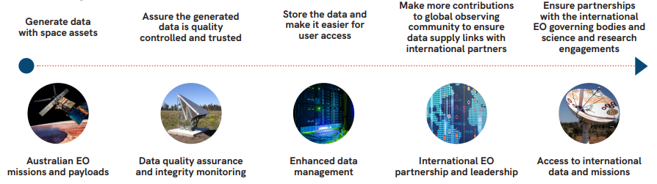

**This roadmap is recommended to be read alongside the following publications.**

Australian Civil Space Strategy 2019-2028

2020 Defence Force Structure Plan

2020 Defence Strategic Update

Australian Academy of Science – Australia in Space: a strategic plan for space science – Draft, due 2021

Australian States and Territories – Space Strategies

SmartSat CRC 2030 Space and Spatial Industry Growth Roadmap – Draft, due 2021

‘Australian Earth Observation Community Plan 2026: Delivering essential information and services for Australia’s future’- Australian Earth Observation Community Coordinating Group 2016

National Earth Observations from Space Infrastructure Plan 2016

CSIRO Space – A Roadmap for unlocking future growth opportunities for Australia 2018

Australian Space Agency, GA, BOM, CSIRO Bushfire Earth Observation Taskforce Report 2020

UNSW Canberra Technical Feasibility Study into an Australian Satellite Cross-Calibration Radiometer 2021

Deloitte’s “Economic study into an Australian continuous launch small satellite program for Earth Observation” 2021

FrontierSI/EOA/SmartSat CRC’s “AusCalVal: Establishing Australia as a Global Leader in Delivering Quality Assured Satellite Earth Observation Data” 2021

CSIRO, SmartSat CRC Preliminary Concept Study for the Satellite Segment of AquaWatch Australia 2021.

Australian Bureau of Meteorology Mission Pre-Phase A Mission Study Report 2021

UNSW Canberra Pre-Phase A Study for the Australian Development of a Satellite Cross-Calibration Radiometer (SCR) series including potential to support partner land imaging programs 2021

ANU OzFuel Pre-Phase A Study, 2021

**Acknowledgements**

The Australian Space Agency is grateful to all those who participated in the roadmap’s development to refine the analysis of Australia’s capabilities and identify the best opportunities for our industry’s future.

* Geoscience Australia
* CSIRO (Commonwealth Scientific and Industrial Research Organisation)
* Bureau (Bureau of Meteorology)
* DST Group
* Department of Defence
* Office of National Intelligence
* Australian Geospatial-Intelligence Organisation
* New Zealand Space Agency
* Earth Observation Australia Inc.
* Curtin University
* Australian National University
* University of NSW Canberra
* University of Western Australia
* The University of Queensland
* SmartSat Cooperative Research Centre
* Space Industry Association of Australia
* Australian Academy of Science

1. Deloitte (2021), Economic study into an Australian continuous launch small satellite program for Earth observation.
2. Australian Space Agency (2019), Canberra: Commonwealth of Australia, 2019, accessed 21 Sep 21. https://publications.industry.gov.au/publications/advancing-space-australian-civil-space-strategy-2019-2028.pdf
3. This includes all activities associated with the practice and science of EO.
4. (Mordor Intelligence, 2019, p. 11)
5. (Asia-Pacific Economic Cooperation, 2019, p. 2) Figures are for both Remotely Sensed and In-situ EO.
6. The Exclusive Economic Zone (EEZ) is an area beyond and adjacent to the territorial sea where Australia has sovereign rights for the purpose of exploring and exploiting, conserving and managing all natural resources of the waters superjacent to the seabed and of the seabed and its subsoil.
7. Deloitte Access Economics, Economic study into an Australian continuous launch small satellite program for Earth observation, 2021, p. 7.
8. <https://www.homeaffairs.gov.au/how-to-engage-us-subsite/Pages/maritime-surveillance-capability-project.aspx>
9. <https://www1.defence.gov.au/sites/default/files/2020-11/2020_Force_Structure_Plan.pdf>
10. <https://www.environment.gov.au/about-us/international/2030-agenda>
11. <https://www.industry.gov.au/policies-and-initiatives/australias-climate-change-strategies/international-climate-change-commitments>
12. <https://www.dfat.gov.au/development/topics/investment-priorities/building-resilience/drr/disaster-risk-reduction-and-resilience>
13. These systems include satellites with appropriate sensors, ground stations, and processing and storage capabilities; all reliant on a skilled workforce.
14. (Australian Government, Department of Defence, 2020, p. 40) and (Australian Government, Department of Defence, 2020, “Defence Enterprise Factsheet”)
15. Australian Government, Make it Happen: The Australian Government’s Modern Manufacturing Strategy,

    https://www.industry.gov.au/data-and-publications/make-it-happen-the-australian-governments-modern-manufacturing-strategy/our-modern-manufacturing-strategy
16. Geoscience Australia, http://www.ga.gov.au/news-events/features/40-years-of-landsat-in-australia
17. For example, ground-based sensors can link water trough levels and cattle locations with satellite observations of vegetation health, cloud patterns and weather forecasts to facilitate livestock and pasture management.
18. Defence Enterprise Fact Sheet <https://www1.defence.gov.au/sites/default/files/2020-11/Factsheet_Enterprise.pdf>
19. *https://frontiersi.com.au/wp-content/uploads/2021/05/FrontierSI_AusCalVal_27052021_Final.pdf*
20. Australia already hosts seven of the top 10 ranked quality assurance supersites worldwide, as recognised by the Committee on Earth Observation Satellites’ (CEOS) Working Group on Calibration and Validation (WGCV) <https://ceos.org/ourwork/workinggroups/wgcv>.
21. This would realise a national priority identified in the Australian Earth Observation Community’s 10 year plan 2016-2026.
22. <https://frontiersi.com.au/auscalval/>
23. Australian Space Agency, Communications Technologies and Services Roadmap 2021-2030, Dec 2020